Getting Setup on W3Schools
- Go to https://w3schools.com
- Click on the Sign In button in the upper-right and then click on Register.
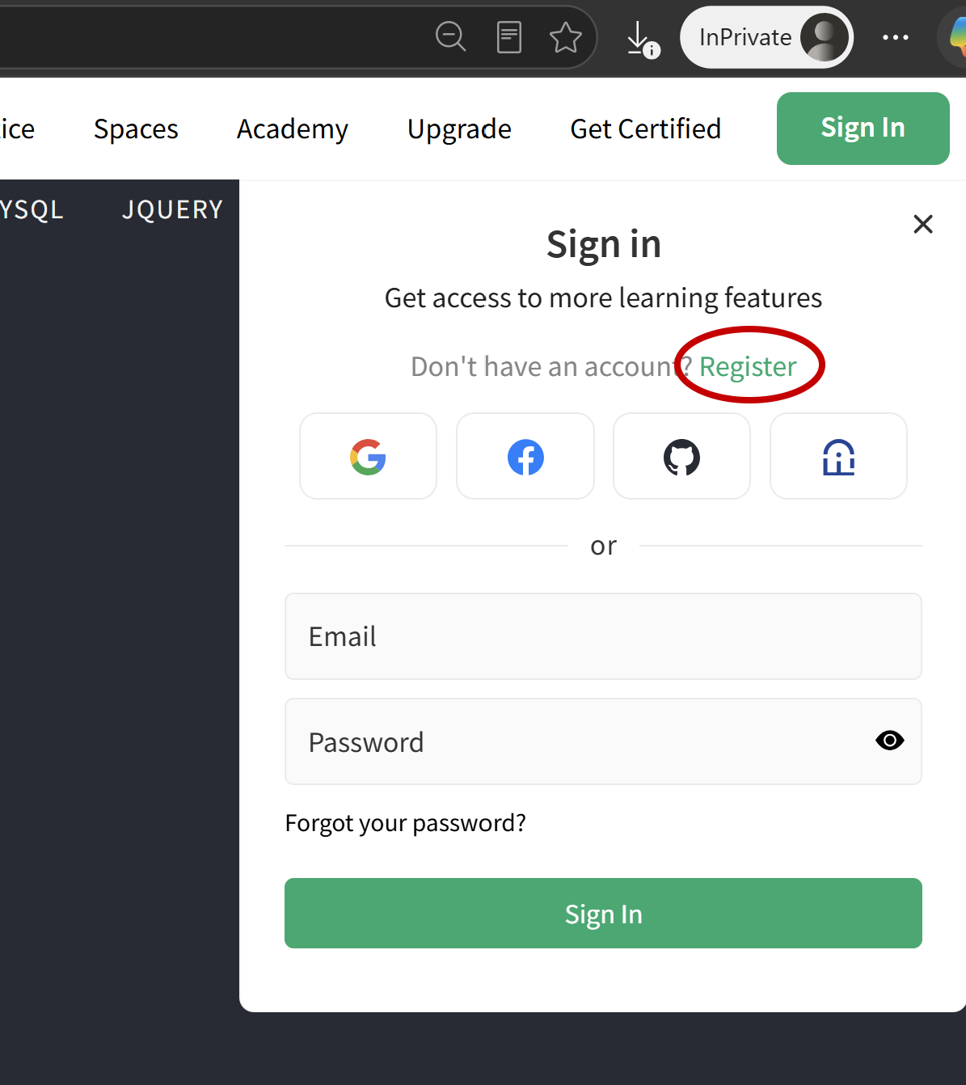

- Fill out the form and click Create Account.
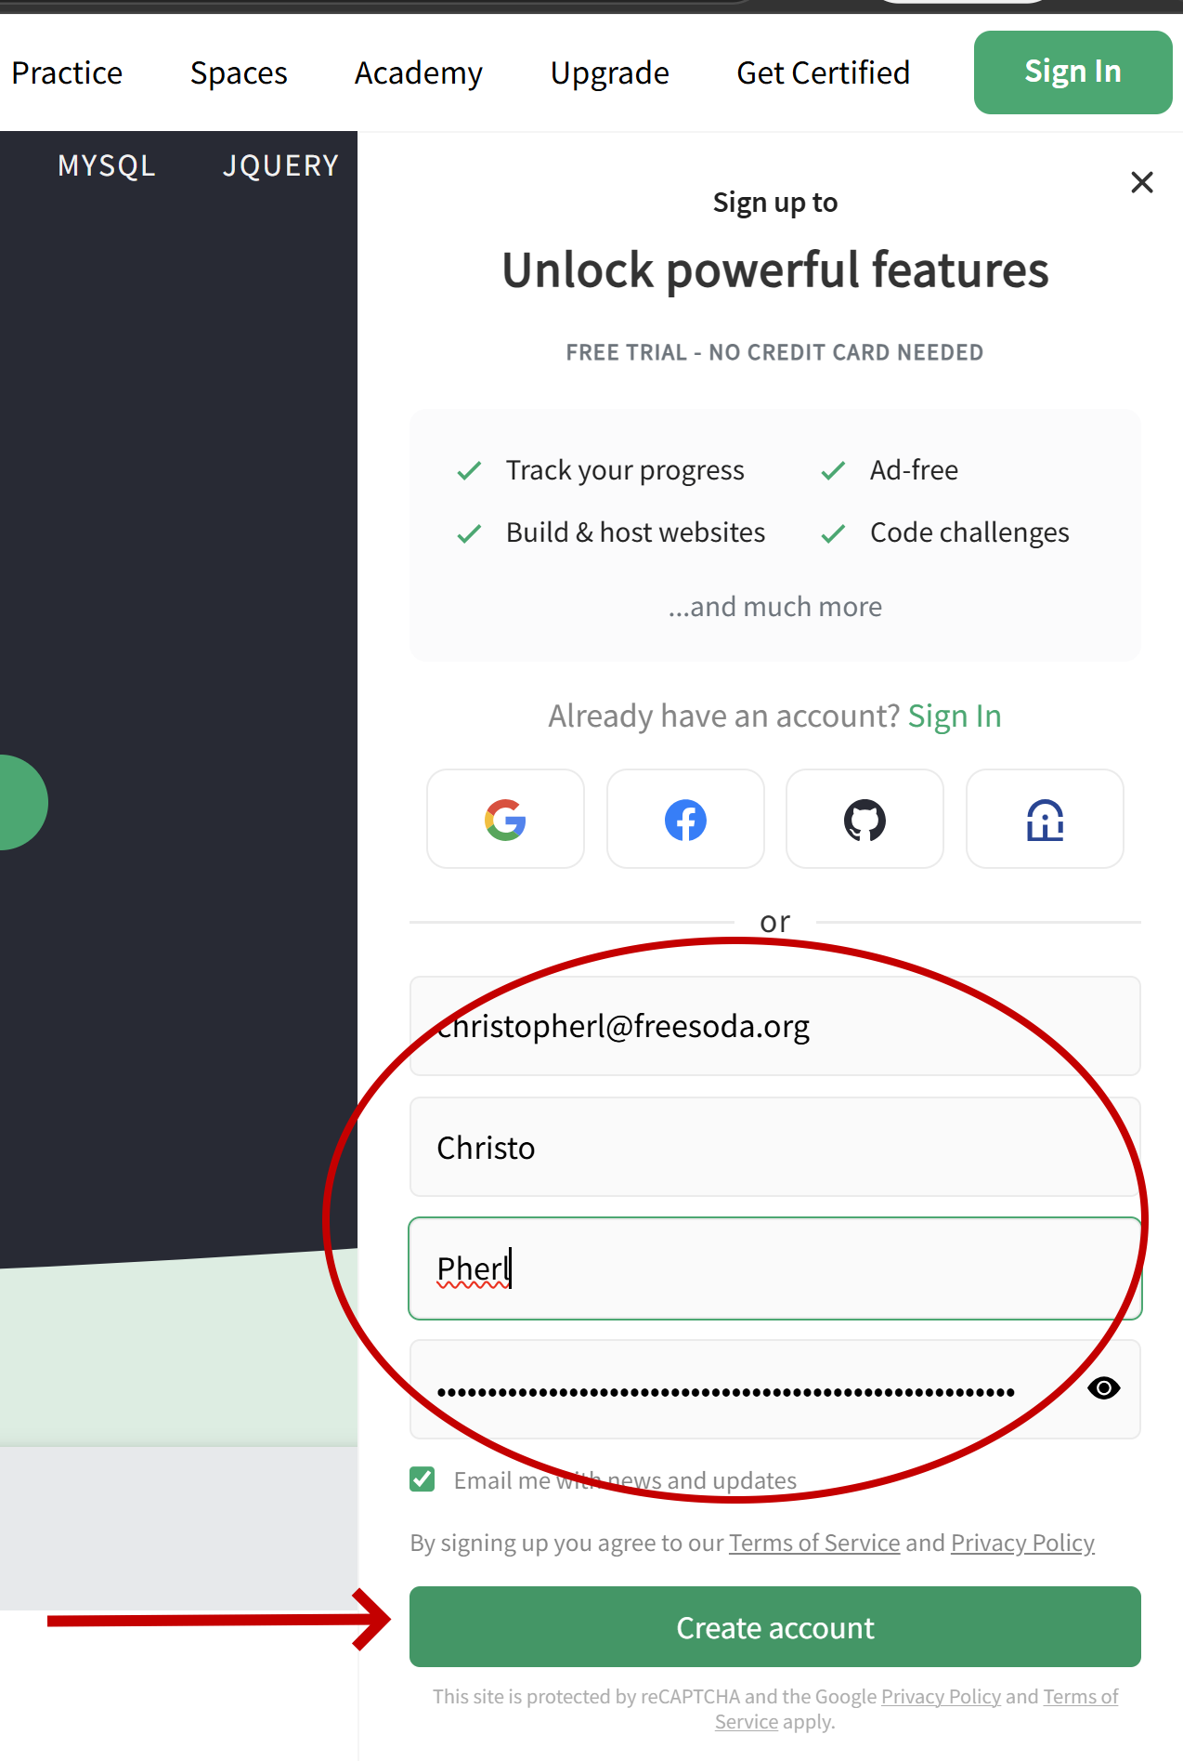

- Go to your inbox; find the email; follow the instructions.
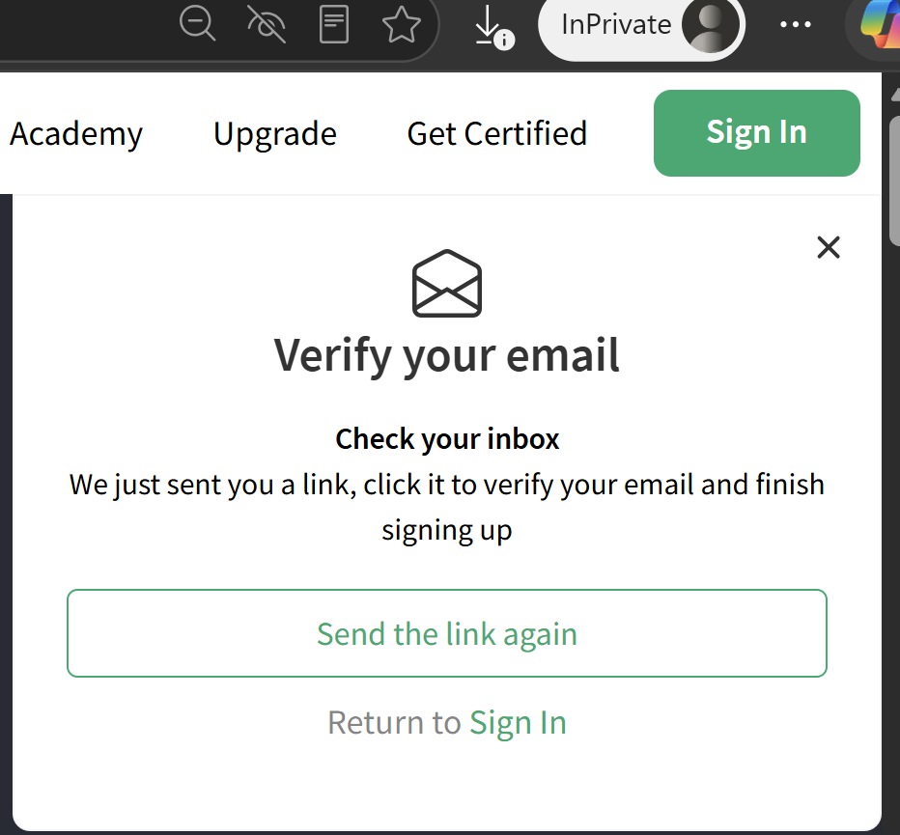

- This will log you in and bring you to this page.
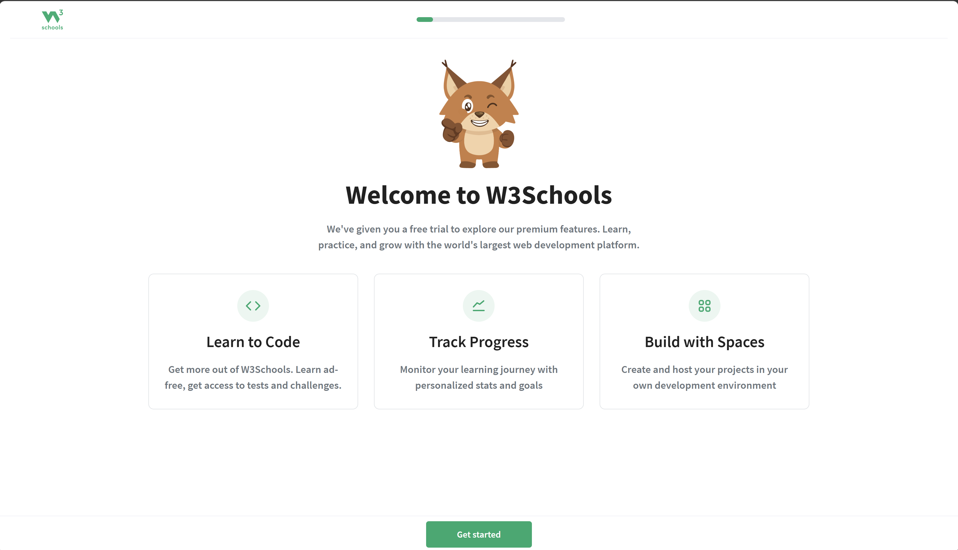
This will force you to primp your avatar, pick a nickname, and so forth. Do whatever you want on the first few screens, but then please choose the following:
Choose the plain, boring Programming option on this page. You can come back later and study the other tracks.
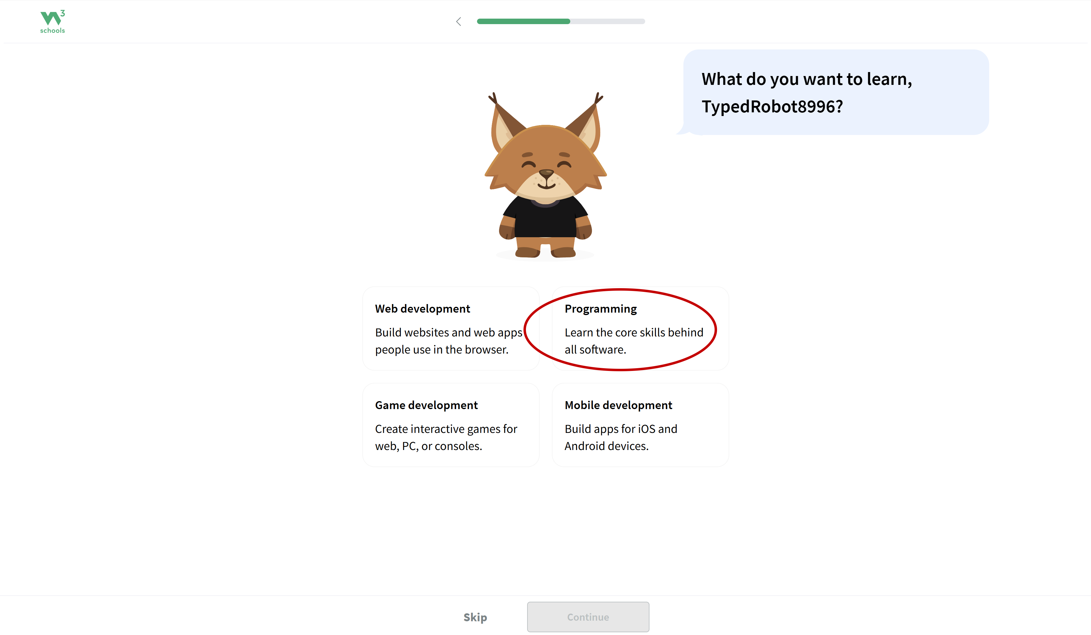

On the screen to choose a language, choose Python.
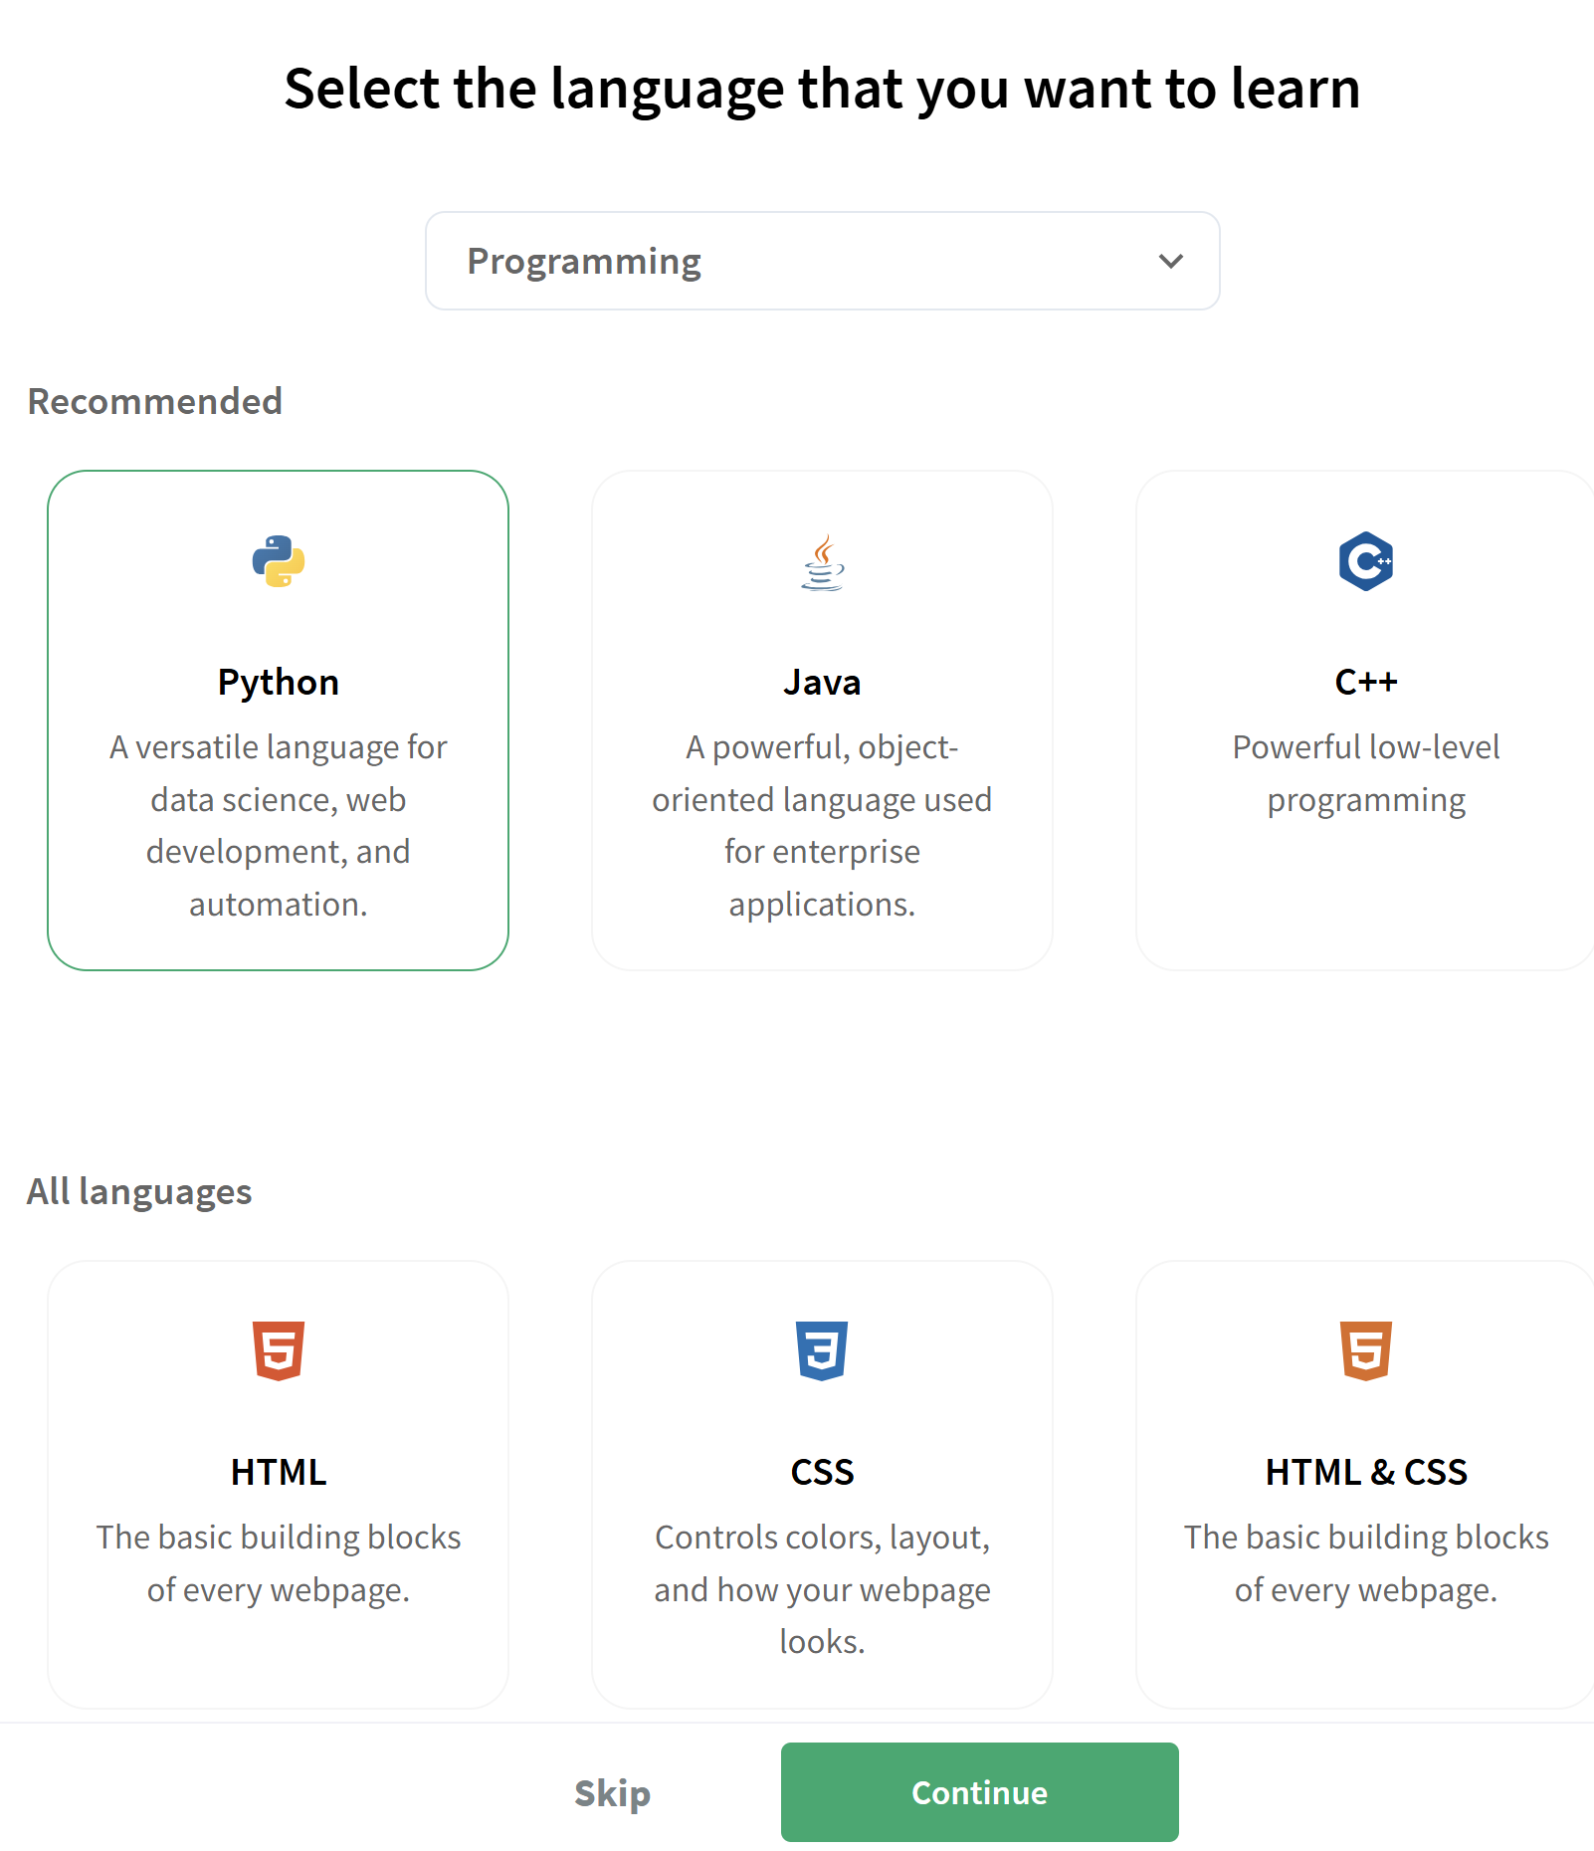
There will be one more screen after this one with a Continue button on it. After that, there is something about a free trial that you can’t turn down, so click the Start Learning button.

